Identifying Real vs Synthetic Images using Deep Learning approaches.
Smriti Siva. May 2025.

Abstract
The increasing sophistication of Artificial Intelligence (AI) generated images presents a challenge in discerning real images from fake ones, with significant implications for information credibility. This paper explores the effectiveness of Error Level Analysis (ELA) and Convolutional Neural Networks (CNNs) for this task with training on the CIFAKE dataset. We trained a simple Deep CNN architecture on the original images, their ELA transformations and a combined dataset, comparing the performance against a basic median-split ELA classifier. Our results show that the model trained on original images outperformed the same model trained on ELA images and the performance of the median-split classifier. Furthermore, the combined model did not improve classification accuracy, indicating that adding ELA transformed images to the training did not make a difference in detecting real from fake images.

- Introduction
The proliferation of sophisticated artificial intelligence (AI) models capable of generating increasingly realistic images presents a challenge in distinguishing between authentic photos from AI-generated ones [1, 2, 3, 5, 7, 16]. As AI models become more adept at producing convincing fakes, concerns arise about the potential for public manipulation, the creation of deep fakes, and the dissemination of misinformation. Individuals could be potentially targeted by fake images to cause distress and reputational damage [18]. Fake images of politicians and protestors can be used to maliciously influence elections and policy decisions [19]. Fake visuals can artificially evoke widespread public panic that can cause further alarm and macro-economic repercussions [20].
The challenge of distinguishing real from AI-generated images has spurred significant research across academia, leveraging diverse techniques ranging from rule-based algorithms to deep learning models [5]. Researchers have explored frequency domain analysis to identify artifacts left by AI generation through techniques like Fourier and wavelet transforms. One example is a model proposed by Wolter et al. [9] to detect deep fakes generated by generative adversarial networks (GANs) and diffusion models (DMs) [4, 5, 6]. Simpler Neural network-based detectors, particularly convolutional neural networks (CNNs), are trained on datasets such as CIFAKE to learn distinguishing features [1, 3]. Attention mechanisms enhance detection accuracy by specifically focusing on relevant features in the image such as the manipulated regions [11]. Efforts are also being made into GAN fingerprinting, and blind forensics, to identify the specific AI that created an image and to detect fakes without prior knowledge [10]. The development of larger and state of the art public datasets have also been crucial in image analysis for deep fake detention.
In this paper, we compare and contrast several approaches to identifying real (original/camera generated) vs fake (computer generated or manually modified) images. Our contributions include an evaluation of a simple Deep CNN architecture for the binary classification of real and AI-generated images on the CIFAKE dataset, an investigation into the utility of ELA as a preprocessing step for enhancing the detection capabilities of our model. This paper also includes a comparative analysis of our CNN-based approaches against a baseline ELA-based median split classifier and existing state-of-the-art methods reported in the literature, demonstrating competitive performance with computationally efficient models.

- Background
2.1 Literature review
Various attempts have been made to identify fake images through both rules-based algorithms and machine learning models. Some proposed methods for image tampering (in cases of copy-move forgery, splicing, and retouching) include wavelet transformers, a type of visual transformer (ViT) [14], and/or error level analysis (ELA) via JPEG lossy compression, as commonly utilized in digital image forensics [2, 5, 7]. That said, anti-forensics techniques developed by Stamm et al. [8], have effectively hidden artifacts detected by wavelet analysis and ELA, complicating the detection process [5, 8]. In this context, CNNs and other deep learning algorithms have been paired with ELA for identifying morphed images. Kotti et al. [2] reported a 91% accuracy rate using this approach, slightly outperforming a model combining ELA with ResNet18 and the k-nearest neighbor algorithm (KNN) (89.5%) [7]. Other preventative measures explored include GAN fingerprinting including adversarial data augmentation Some machine learning algorithms have even reached levels close to perfect accuracy, such as a model proposed by Volkova et al. [5], which reach a 99% accuracy rate identifying manipulated images through “face swapping” preprocessing.
2.2 Challenges
Despite modern achievements in image detection, increasing public access to editors and AI models makes it harder to enforce preventative measures against image tampering and forgeries [5]. In a similar vein, constantly evolving forms of image generation and ways to prevent getting caught (like in the case of anti-forensics and GANs) only make it harder to create models which can catch up, creating a lack of “ground truth labels” to compare with [4, 5, 6, 8]. Singh & Kumar [5] also mention the risk of adversarial attacks, which can be used to deceive detection algorithms, challenging their robustness.
With the advent of complex generated images, traditional methods which use an algorithmic approach to detect fake images, such as ELA, are less effective. In this paper, we attempt to answer the question whether we should try to enhance the potency of the ELA algorithm by combining it with machine learning techniques, or abandon it in favor of more modern techniques?”

- Methods
3.1 Dataset and preprocessing
For our research, we used the CIFAKE dataset [3], which is a comprehensive collection of real and AI-generated images designed for computer vision and machine learning tasks. The CIFAKE dataset consists of 60,000 real images and 60,000 synthetic images generated by the Stable Diffusion Gen AI model. These are low resolution, RGB color images with a dimension of 32x32 pixels. These images are split into training and test data where we have 100,000 training (50,000 real and 50,000 fake) images; and 20,000 test (10,000 real and 10,000 fake) images. These images were pre-processed using the python torchvision package and converted to a tensor (dimensions 3 x 32 x 32), so that it can be used to train a deep neural network.
3.2 Modeling Approaches
We created a deep CNN model for binary classification - the real vs fake (AI-generated) images in the CIFAKE [3] dataset. The model has three convolutional layers (with 32, 64, and 128 filters) followed by max pooling layers. This is followed by two fully connected layers. The first fully connected layer compresses the flattened features from all the convolutional layers into a 256-dimensional vector, followed by a parametric ReLU, which adaptively handles negative values in the weights matrix of the neural network. The final fully connected layer maps the 256 dimensions to 2 output nodes (“real” and “fake”). The final layer is followed by a SoftMax transformation that creates probability scores for each class. Using design choices such as the pooling layer helped prevent overfitting. A kernel size of 3x3 helped balance capturing local features while keeping the model computationally efficient. We prioritized model simplicity by opting for only three convolutional layers which enabled hierarchical learning without the complexity. The model architecture is shown below (architecture diagram in Appendix A) -
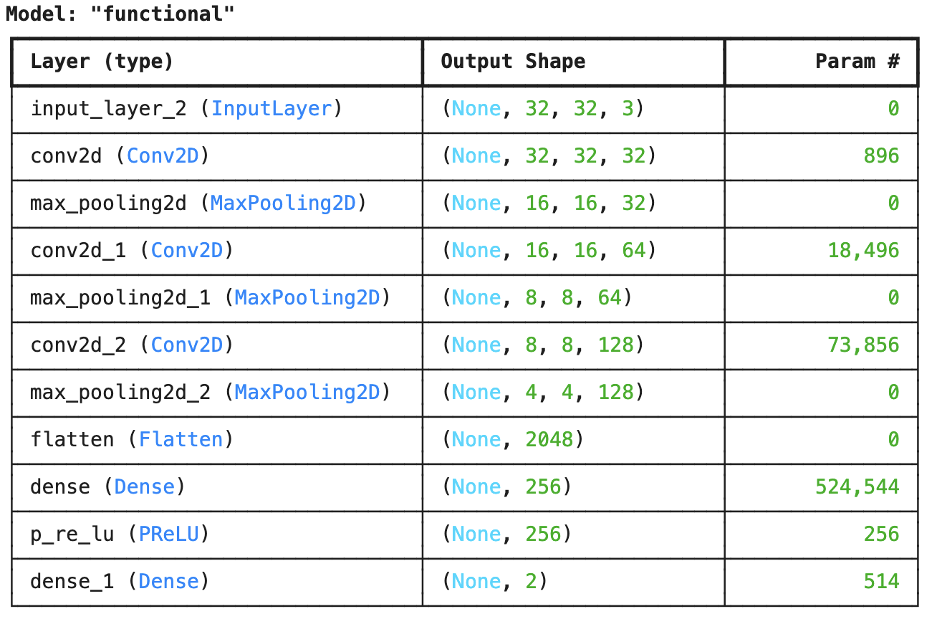

During training, we measured the performance on both the train and test datasets for every batch cycle. Performance metrics (accuracy, f1, and loss scores) were saved after every batch training cycle. This helped us better understand the model’s learning process through the iterations, so that we could adjust hyperparameters accordingly for the next model training run.
We also attempted out of sample learning against the “140 Real and Fake Faces” dataset [16], which required reshaping each image into 32x32 pixels from 256x256 pixels, which resulted in a significant loss in detail and therefore detection accuracy. Since the CIFAKE dataset doesn’t focus on face detection, the model was not expected to perform highly.
3.3 Hyperparameter tuning/optimization
After hyperparameter tuning, the most accurate results (92%) came with a learning rate of 0.001 and using the Adam [15] optimization algorithm. Adam optimization combines Momentum and RMSprop to adapt learning rates for each parameter during neural network training. It uses exponentially weighted moving averages of past gradients (momentum) and squared gradients (RMSprop) to efficiently navigate the loss landscape. Adam also incorporates bias correction to counteract initial zero-value biases, leading to faster convergence and improved performance. The optimizer equation [21] is shown below, where:
- m_{t}​ is the moving average of the gradients at time t,
- $η$ is the learning rate,
- w_{t​​} and wt-1 are the weights at time t and t-1, respectively.
- vt​​ is the exponentially weighted average of squared gradients
- 𝛆 is a small constant (e.g., 10−810−8) added to prevent division by zero.
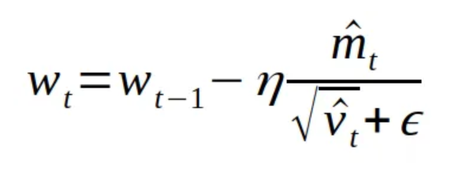
Other possible models to implement include testing out various transform methods for feature extraction, texture analysis, and locating data augmentation. However, for the sake of providing a more direct analysis between this original binary classification model and future testing, keeping the model as rudimentary as possible while maintaining a reasonable accuracy and efficiency was preferable. Training to convergence, the model peaks at around 90% accuracy. This model was used as a benchmark to compare other approaches that we took.
3.4 Error Level Analysis (ELA)
We identified ELA [7] as a method to distinguish real from fake images. ELA analyzes the compression artifacts of an image after having performed a lossy compression. The compression artifacts, based on their contrast from their surroundings, can determine whether a picture has been edited or tampered with. When AI generated images and their real counterparts are fed through this model, they have noticeably different levels of variance in their compression patterns. For untampered, real images, the ELA shows generally uniform brightness, which varies depending on the quality of the original image. The ELA of manipulated fake images show noticeable variations in brightness, which correspond to the boundaries of the manipulated areas, with untampered areas appearing darker than tampered sections of the image. Figure 1 and Figure 2 below show the original real/fake image and ELA-transformed real/fake images respectively.



Figure 1: Original Images (RGB) Figure 2: ELA transformed images
1st row, real CIFAKE 1st row, real ELA
2nd row, fake CIFAKE 2nd row fake ELA
We created the ELA transformations for the real and fake images as a pre-processing step before feeding them through the same binary classification CNN model. This model achieved a mean of 84% accuracy when trained to convergence. Additionally, we applied a logistic regression to the ELA pixels of both the real and fake images to see if an accurate classification could be made outside of a neural network. The regression performed at a 53.8% accuracy, which was just slightly better than a random guess.
3.5 Combined model
We created a custom dataset that merged the normal RGB image data with the ELA transformed image data. We preprocessed the image data to combine the RGB image tensor and ELA image tensor from two [32, 32, 3] tensors to a single [32, 32, 6] tensor. This new tensor accounted for the three new RGB channels from the ELA image transposed on top of the original RGB image. When trained to convergence, the model performed at an accuracy rate of 90%, directly paralleling the results from the original binary classification run with the unaltered images. The poor performance of the classification using ELA images alone, as well as the lack of improvement from merging the ELA and original datasets together, appears to be an indicator that the information from the ELA dataset is not distinguishable enough to classify real images from fake ones.

- Results
The following table highlights the performance in terms of accuracy, f1-score, and compute hours of the models in this research as compared to other state of the art models in the industry.
Model | Accuracy | F1-Score | Compute Resource
Rafique et al. (2023) ELA SqueezeNet (KNN) [7] | 89.5% | 89.5% | N/A
Rafique et al. (2023) ELA ResNet18 (KNN) [7] | 81% | 81% | N/A
Rafique et. al. (2023) ELA GoogleNet (KNN) [7] | 68.8% | 68.5% | N/A
Bird & Lofti (2024) CNN [3] | 92.98% | 90.9% | 1 3080 GPU
Liu et. al., (2022)  ConvNextLarge [13] | 92.54% | 92.54% | N/A
Huang et. al., (2017)  DenseNet201 [14] | 85.96% | 85.96% | N/A
ELA median split | 53.8% | N/A | 0 minutes
Deep CNN (original image) | 90% | 90% | 16 minutes
Deep CNN (ELA) | 84% | 84% | 84 minutes
Deep CNN (combined) | 90% | 90% | 28 minutes
Our CNN model trained on original RGB images had the following accuracy and f1 performance trajectory (figure 3 below) for training and test data, which shows that the model was not over-fitting and had a robust performance on the test data.
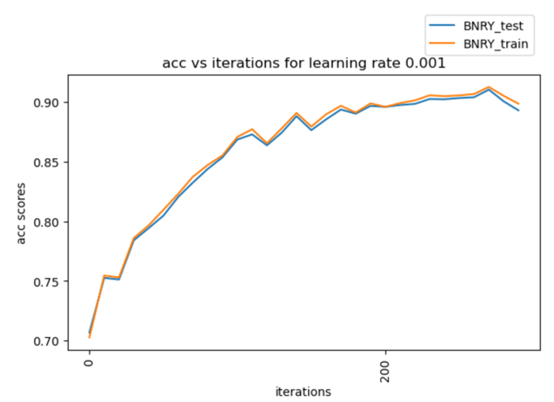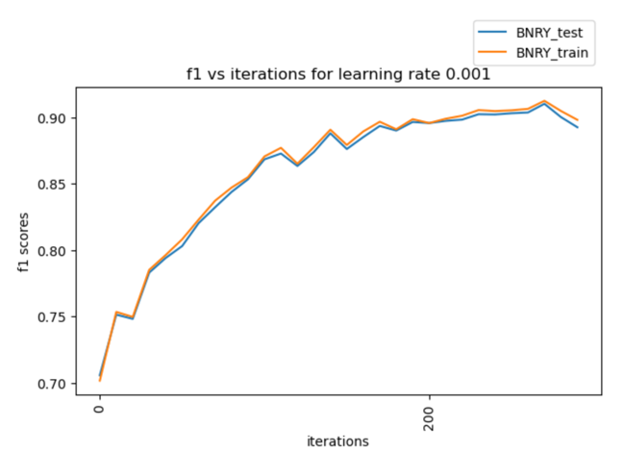
Figure 3: Training curve of CNN on original image data
Our CNN model trained on the ELA images had the following accuracy and f1 performance trajectory (Figure 4 below)) for training and test data. Even though this model did not perform as well, when trained on ELA data, the model was not over-fitting and had a robust performance on the test data.
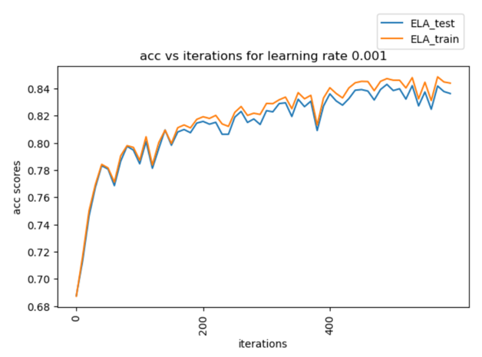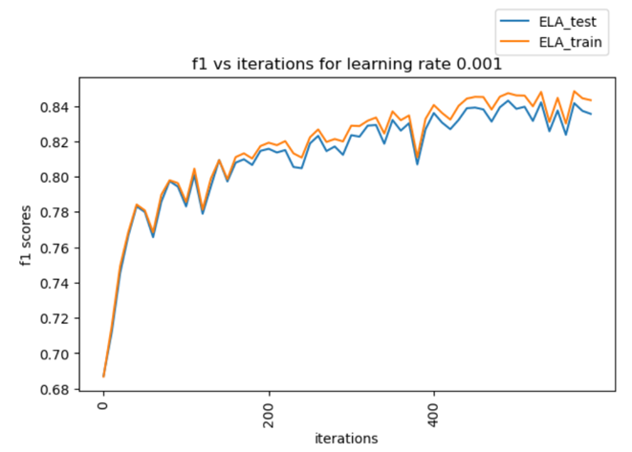
Figure 4: Training curve of CNN on ELA image data

Our final ensemble CNN model trained on original and ELA images had the following accuracy and f1 performance trajectory (Figure 5)) for training and test data. Even though this model did not perform as well, when trained on ELA data, the model was not over-fitting and had a robust performance on the test data.

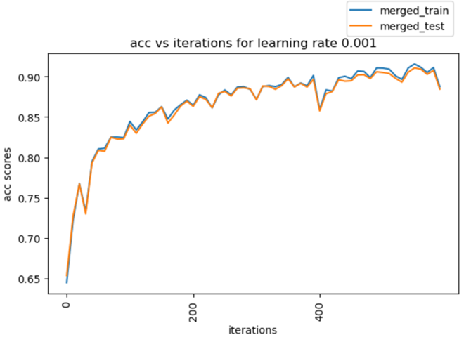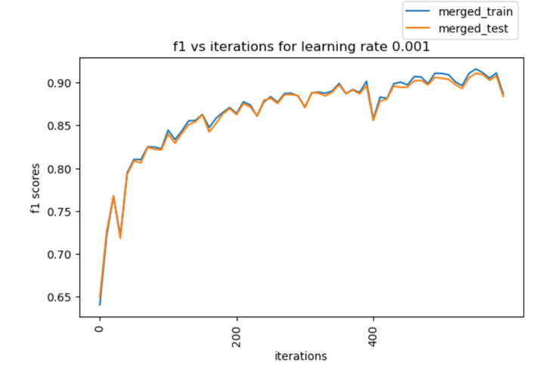
Figure 5: Training curve of CNN on Merged (Original + ELA) image data

Testing on external data (out-of-sample): We attempted testing all the three models on out-of-sample image data (20,000 images – 10,000 real and 10,000 synthetic/fake) from Kaggle [16]. The performance of the three models are shown in the table below –

Model | Accuracy | F1-Score
Deep CNN (image) | 49% | 34%
Deep CNN (ELA) | 50% | 33%
Deep CNN (combined) | 49% | 33%
All three models did not perform well on the out-of-sample data. This implies the models we trained using CIFAKE data were not robust enough to generalize to external data. Unlike the original test data, the out-of-sample test performed with similar accuracy 49%-50%-49% across the three models.

- Conclusion
Our investigation into the detection of real vs AI-generated images using the CIFAKE dataset explored the effectiveness of ELA in tandem with CNNs. The evaluation involved training a simple Deep CNN architecture on the original images, their corresponding ELA representations, and a combined dataset (with original and ELA images).
The principal findings show that the model trained directly on the original images achieved an accuracy of 90%, surpassing the 84% accuracy obtained by that same model trained on the ELA of those same images. Moreover, the integration of ELA data with the original images did not result in improved classification performance and was comparable to the results from the model trained on the original images. Notably, the basic median-split classifier performed the worst out of all the experiments (54% accuracy).
These results suggest a re-evaluation of the ELA approach for the discrimination of real and fake images. While the CNN model demonstrates considerable promise with the simple Deep CNN, further research is necessary to ensure favorable outcomes across more advanced models and varied datasets, perhaps through the implementation of transformer-based architectures. Another possible direction could also focus on assessing how the models deal with adversarial manipulation rather than artifact identification. Finally, extending this line of inquiry to other data to other, more specific scenarios, where the characteristics of AI-generated content may differ, could be a significant step towards developing more robust and reliable detection algorithms.

References

[1] Islam, Md Tanvir, et al. “MEXFIC: A Meta Ensemble EXplainable Approach for
AI-Synthesized Fake Image Classification.” Alexandria Engineering Journal, vol. 116, 1 Jan. 2025, pp. 351–363, www.sciencedirect.com/science/article/pii/S111001682401617X#sec1, https://doi.org/10.1016/j.aej.2024.12.031.
[2] “MORPHED IMAGE DETECTION USING ELA and CNN TECHNIQUES.” Journal of
Pharmaceutical Negative Results, ResearchTrentz, 24 Dec. 2022, www.pnrjournal.com/index.php/home/article/view/5287. Accessed 5 Apr. 2025.
[3] Bird, Jordan J, and Ahmad Lotfi. “CIFAKE: Image Classification and Explainable
Identification of AI-Generated Synthetic Images.” IEEE Access, vol. 12, 1 Jan. 2024, pp. 1–1, https://doi.org/10.1109/access.2024.3356122.
[4] Gu, Siqi, et al. “Multiscale Features Integrated Model for Generalizable Deepfake
Detection.” International Journal of Intelligent Systems, vol. 2025, no. 1, 7 Jan. 2025, www.researchgate.net/publication/387818193_Multiscale_Features_Integrated_Model_for_Generalizable_Deepfake_Detection, https://doi.org/10.1155/int/7084582.
[5] Singh, Satyendra, and Rajesh Kumar. “Image Forgery Detection: Comprehensive
Review of Digital Forensics Approaches.” Journal of Computational Social Science, vol. 7, no. 1, 1 Apr. 2024, pp. 877–915, https://doi.org/10.1007/s42001-024-00265-8.
[6] “The Cat and Mouse Game: The Ongoing Arms Race between Diffusion Models
and Detection Methods.” Arxiv.org, 2024, arxiv.org/html/2410.18866v1. Accessed 24 Feb. 2025.
[7] Rafique, Rimsha, et al. “Deep Fake Detection and Classification Using Error-Level
Analysis and Deep Learning.” Scientific Reports, vol. 13, no. 1, 8 May 2023, p. 7422, www.nature.com/articles/s41598-023-34629-3, https://doi.org/10.1038/s41598-023-34629-3.
[8] Stamm, Matthew C., and K.J. Ray Liu. “Anti-Forensics of Digital Image
Compression.” IEEE Transactions on Information Forensics and Security, vol. 6, no. 3, Sept. 2011, pp. 1050–1065, https://doi.org/10.1109/tifs.2011.2119314. Accessed 19 July 2020.
[9] Wolter, Moritz, et al. “Wavelet-Packets for Deepfake Image Analysis and
Detection.” Machine Learning, 31 Aug. 2022, https://doi.org/10.1007/s10994-022-06225-5.
[10] Liu, Chi, et al. “Disentangling Different Levels of GAN Fingerprints for
Task-Specific Forensics.” Computer Standards & Interfaces, vol. 89, 16 Dec. 2023, p. 103825, www.sciencedirect.com/science/article/abs/pii/S092054892300106X, https://doi.org/10.1016/j.csi.2023.103825.
‌[11] Wang, Jiaying, et al. “Face Forgery Detection with a Fused Attention Mechanism.”
2022 3rd International Conference on Computer Vision, Image and Deep Learning & International Conference on Computer Engineering and Applications (CVIDL & ICCEA), 20 May 2022, https://doi.org/10.1109/cvidliccea56201.2022.9824499. Accessed 29 June 2024.
‌[12] Z. Liu, H. Mao, C.-Y. Wu, C. Feichtenhofer, T. Darrell, S. Xie, A convnet for the
2020s, in: Proceedings of the IEEE/CVF Conference on Computer Vision and Pattern Recognition, 2022, pp. 11976–11986.
[13] G. Huang, Z. Liu, L. Van Der Maaten, K.Q. Weinberger, Densely connected
convolutional networks, in: Proceedings of the IEEE Conference on Computer
Vision and Pattern Recognition, 2017, pp. 4700–4708.

[14] Dosovitskiy, Alexey, et al. “An Image Is Worth 16x16 Words: Transformers for
Image Recognition at Scale.” ArXiv:2010.11929 [Cs], 22 Oct. 2020,
arxiv.org/abs/2010.11929.
[15] Kingma, Diederik P, and Jimmy Ba. “Adam: A Method for Stochastic
Optimization.” ArXiv.org, 22 Dec. 2014, arxiv.org/abs/1412.6980.
[16] Aniano Porcile, Gonzalo, et al. Finding AI-Generated Faces in the Wild.
[17] “140k Real and Fake Faces.” Www.kaggle.com,
www.kaggle.com/datasets/xhlulu/140k-real-and-fake-faces.
[18] Mustak, Mekhail, et al. “Deepfakes: Deceptions, Mitigations, and Opportunities.”
Journal of Business Research, vol. 154, no. 113368, Jan. 2023,
https://doi.org/10.1016/j.jbusres.2022.113368.
‌[19] Barari, Soubhik, et al. “Political Deepfakes Are as Credible as Other Fake Media
and (Sometimes) Real Media.” The Journal of Politics, 16 Sept. 2024,
https://doi.org/10.1086/732990.
[20] Shamo, Sebastian Anetey. “The DeepFake and Its Impact on Trading Signals.”
Ssrn.com, 8 Aug. 2024, papers.ssrn.com/sol3/papers.cfm?abstract_id=5070125.
[21] GeeksforGeeks. “What Is Adam Optimizer?” GeeksforGeeks, 22 Oct. 2020,
www.geeksforgeeks.org/adam-optimizer/.

‌

Appendix A - Deep CNN model architecture
